How to Make a Table Top Worm Bin

Becky Griffin

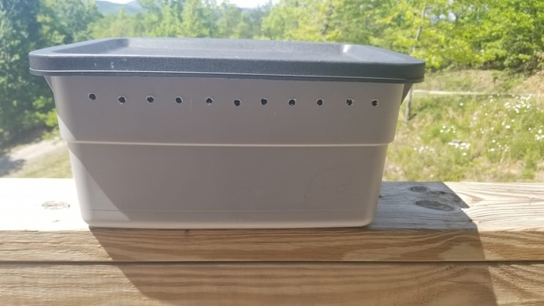

Find a soft, pliable, opaque plastic container with a lid that is easy for you to carry. These are readily available at big box retailers or hardware stores.

About two inches from the top drill holes around the perimeter of the container approximately 1/4 inch in diameter. This will help add air to the bin. These should be far enough up the container that the worms cannot crawl up to the holes and escape.

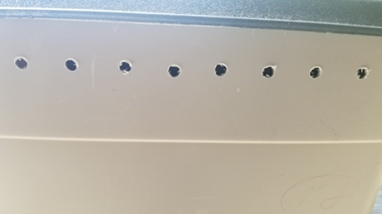

On each side of the bin drill a hole larger in diameter. In this example I used the same drill bit size, connecting them to make a larger hole.
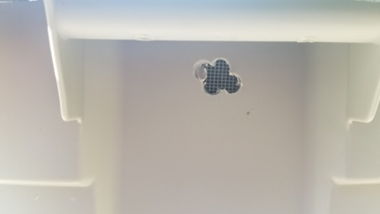

Add screens and tape the screen down inside the bin. This also aids in air circulation.

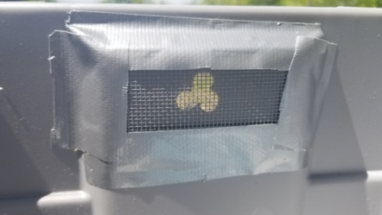

Add torn newsprint to the bottom of the bin and you are ready to add your worms.

Note: It is important to keep the system slightly damp but not wet. The drilled holes will help with that. If you need to add moisture using a squirt bottle on the mist setting should work.

